STATISTICS BASICS
Data Types & Patterns & Graphs
EXERCISE 1. At what level are each of the following variables operationalized?
Numerical (Continuous/Discrete) or Categorical (Nominal/Ordinal)
 | Variable Name | Value Labels | Data Type
1 | Age | 1, 2, 3, .... | Continuous
2 | Sex | male, female, other | Nominal
3 | Class standing | freshman, sophomore, junior, senior | Ordinal
4 | Marital Status | married, single, divorced, widowed | Nominal
5 | Median Household Income | annual household income in dollars | Continuous
6 | How much do you like the food on campus? | a lot, some, a little, other | Nominal
7 | The number of toxic waste sites in your community | 0, 1, 2, 3, .... | Discrete
8 | The number of toxic waste sites in your community | 0, 1–5, 6–10, 11+ | Ordinal
9 | Your GPA | below average, average, above average | Ordinal

EXERCISE 2. Go to the National Opinion Research Center’s 2008 General Social Survey Codebook at http://sda.berkeley.edu/D3/GSS08/Doc/gs08.htm (Alphabetical Variable List). What are the types of data for the following variables?
Variable Name | Data Type | Variable Name | Data Type
ABLEGAL | Ordinal | MUSICALS | Ordinal
ACTLIT | Nominal | NATBORN | Nominal
ADULTS | Discrete | NUMKIDS | Discrete
AGE | Continuous | PAINCURE | Ordinal
BIBLE | Nominal | POLVIEWS | Ordinal
BLKZONE | Ordinal | RACE | Nominal
CARSGEN | Ordinal | SEX | Nominal
CONROCK | Ordinal | TRUST | Nominal

EXERCISE 3. The number of passengers of an airline company by years is given in the table below. Create a bar chart based on these data.
Years | 2010 | 2012 | 2013 | 2014 | 2015 | 2016 | 2017 | 2018 | 2019
Number of passengers (x1000) | 5 | 7 | 13 | 10 | 20 | 22 | 17 | 16.5 | 27
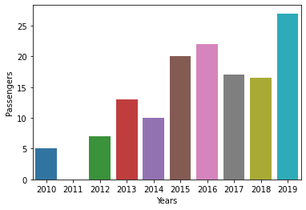

EXERCISE 4. Create a frequency histogram from the data in the table below. What can you conclude about the shape of the distribution?
Income (In thousands of dollars) | Number of families
16-22 | 2
23-29 | 3
30-36 | 5
37-43 | 8
44-50 | 8
51-57 | 10
